Project proposal

ON

Gym management system



Anil Thapa

00170383

Computing project

Level 5 in Computing

Softwarica college of IT and E-commerce

Mahakabi marga dillibazzar, Kathmandu

04/03/2019

Submitted to: Niman Maharjan

# Introduction

## 1.1 Project introduction

The development in technology brings the development and comfort in the life style of the people. Due to which people fitness can be the major problem for them. So, to get the physical fitness people join the fitness for the workout. The day with the people information can be more precious todays. To manage information traditional methods is time consuming. So, to manage the flow of work on simultaneously gym management manages it. This system helps to keep the information on systemic way. The system can be run on the particular device like desktop and laptop.

## 1.2 Justification for project

### 1.2.1 Background of project

Gym management system is desktop-based application where you can store the data of each members. This helps to manage the details of all your builder, trainer and other activities between them. Timetable for the booking for the new trainers. And the period of time they able to attend. The system can store the different data of customer where as user friendly graphical user interface (GUI). For this project data is stored in MY (SQL) and visual studio 2015 for the interfaces. Customer can get the details form the management if needed.

### 1.2.2 Problem statement

Keeping the records scientifically brings the management more reliable. Traditional methods can be more difficult so this system manages all the activities on the gym section from the single counter. Each of details can be only achieve from the system where it placed. Manual system for the data entry and time consuming if the records is more. Searching of the data can be more difficult or performance quite long as data increase.

For the different data different form should be manually update which makes user more tedious. The whole process can be more cumbersome for manually control. Overcomes of the data redundancy can be problem. Better user interface and time and flexible system.

## 1.3 Description of project

### 1.3.1 Features of system

* Login and registering for the user through admin:

Only the particular user can login and register for the others. So, it consists of password and username for valid users to access from database.

* Admin can delete and update data:

Second most features that information that no longer valid user can be deleted from the system users.

* User can call for the report:

Each of the information of the user can be retrievals if valid user claims their information.

* items can be sales recorded and their price:

Items purchase can be detailed into the system.

# 2. Project scope

## 2.1 Scope and limitation

Scopes

Particularly, used to keep the data of customer that involves in the gym. Keeping the data for the further used. Helps to retrieve the number of customer and available schedules for them. Schedule, workout, diet can be trace.

Limitations:

No biometric verification on the system and can be done manually. No digital payment is available on the system and banking system on place.

## 2.2 Aims

* The main function aims of system is to manage the data that belongs the customer.
* To manages the redundancy of data between them.
* To search the data with the faster output. Track and manages the resources for the available customers.
* Timetable for the appropriate with customer satisfaction.
* To handle the day to day customer data and store in the database.
* Reducing the tedious from work and smoothness on the management system.

## 2.3 Objectives

* Reduce the redundancy of data and provide the complete set of packages with profit motive.
* To manages overall resources with available customer and add to the profit for the organization.
* To reduce the time and manage the resources from the organize.
* Better service at high level of system.
* Low use of resources for profit motive with manageable and technical products.

Overview of the scope

Every important and major properties of the projects scope described. Limitation defines the basic limit of the software that meet the requirement captures. Except the limitation the software does not perform better than that. The main aim of the project described on the aims of the project. Defines the major performance of the projects. It shows actual requirement on the function needs for people. What kinds of benefits brings from the system over them?

# 3. Development methodology

The development of methodology on software development apply according to the projects. Various available on the techniques. Since, this steps of following depends upon the nature of the product. Some of them described below:

## 3.1 Waterfall model:

It is the first model of software development life cycle. In this phase each phase must be complete before the next phases. Overlapping of the step does not preferred to this methodology. The sequential design process of waterfall model is conception, imitation, analysis, design, testing, implementation.

Water fall model is chosen as:

* Due to the flow of data.
* Steps of process and tasks
* Simple easy to understand
* For a small project requirement can be understood

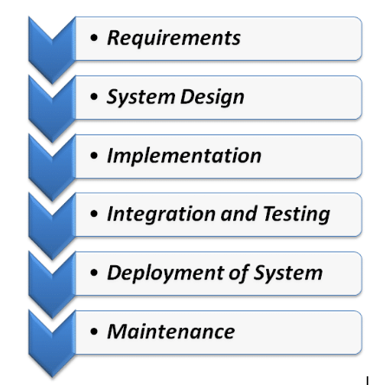

Figure : waterfall diagram

## 3.2 Design pattern:

Design pattern is the tested, proven development method where speed up the development. Design pattern improves the issues and the major causes improves readability of code for coders. Generally, design pattern allows the communication between developer and the understanding of the project.

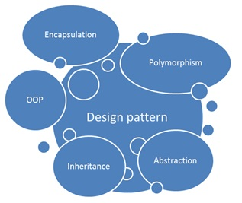

Figure : design pattern

## 3.3 Model, View, Controller (MVC) pattern:

This pattern is formed by the combination of model, view, controller in which model and view represent on same category where as controller is beside these. This MVC framework is the tending framework for todays. In this desktop-based application MVC pattern is used. The MVC represent as:

Model: describe the set of class and data working on it as well as business logic.

View: represents the user interface (UI) visual represent of how it looks like.

Controller: communication, logical part, flow of application consists on it. Interaction between the model and view. (tutorialspoint, n.d.)

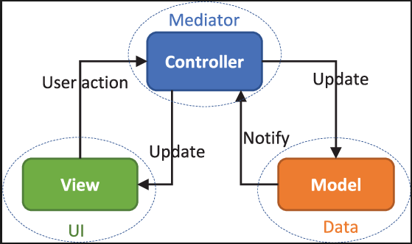

Figure :MVC pattern

## 3.3 System architecture:

It is the architecture design of the system. Basic thing is to divide the task into component. Component helps to redefine the task and reusability. The process, performance, costs, optimization, reliability depends upon the how well the architecture define or sketch. (Spacey, 2018)

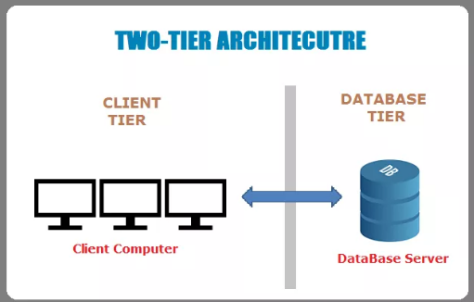

Figure :two tire system architecture

# 4. Project plan

## 4.1 Work breakdown structure (WPS)

Work breakdown structure is the process of separating task into component in order to reduce the work load. Complex task can be decomposed into sub task.

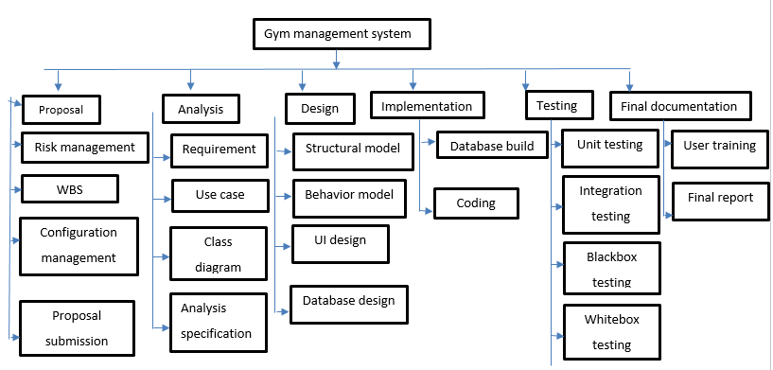

Figure :Work breakdown structure(WPS)

## 4.2 Milestone

|  |  |  |
| --- | --- | --- |
| **Milestones** | **Start Date** | **Finish Date** |
| **Project management**  Risk management  WBS  Configuration management  Proposal submission | **03-25-2019**  03-25-2019  03-29-2019  04-02-2019  04-06-2019 | **04-09-2019**  03-28-2019  04-01-2019  04-05-2019  04-09-2019 |
| **Analysis**  Requirement  Use case  Class diagram  Analysis specification | **04-10-2019**  04-10-2019  04-17-2019  04-24-2019  05-01-2019 | **05-08-2019**  04-16-2019  04-23-2019  04-30-2019  05-08-2019 |
| **Design**  Structural  Behavior model  UI design  Database design | 05-09-2019  05-09-2019  05-15-2019  05-22-2019  05-28-2019 | **06-03-2019**  05-14-2019  05-21-2019  05-27-2019  06-03-2019 |
| **Implementation**  Database built  Coding | **06-04-2019**  06-4-2019  06-10-2019 | **06-24-2019**  06-09-2019  06-24-2019 |
| **Testing**  Unit testing  Integrating testing  Blackbox testing  Whitebox testing | **06-25-2019**  06-25-2019  06-27-2019  06-29-2019  07-01-2019 | **07-01-2019**  06-26-2019  06-28-2019  06-30-2019  07-01-2019 |
| **Final documentation**  User training  Final report | **07-02-2019**  07-02-2019  07-08-2019 | **07-12-2019**  07-07-2019  07-12-2019 |

### 4.2.1 Description of milestone:

Project management:

For the initial phase of project total days 16. Out of which for the each of task 4 days has been allocated. The task has following subtasks risk management, work breakdown structure (WBS), configuration management, proposal submission.

Analysis:

For the first tasks after the project management analysis of the project 29 days has been allocated. For the requirement, use case, class diagram 7 days for each has been allocated. And for the analysis specification 8 days has allocated to task.

Sketching use case take quite too long due to user interaction shown in the diagram with system as for the class diagram relationship or flow of data between entities.

Design:

In this task time table is separated as 6 and 7 for structural, behavioral design days for UI and database built as same as days located to them.

It is good to allocate good UI and behavior design to increase the acceptance of prototype.

Implementation:

This is the foremost task in which more time and core logical part hits on program. In this process database built and the coding parts comes on it. So, estimate time is 6 and 15 days for database built and coding respectively.

Allocation of the days for the database built to reduce the unnecessary use of data and coding took time to match the requirement and logical.

Testing:

Testing part of this task includes the validation of the data over the products. Validating either the system data is correct or not. This includes unit testing, integration testing, black box testing and white box testing. The time estimated to them are 2 days respectively except 1 days for last one.

To check for the validation of the data and their result days has been allocated as.

Final documentation:

For the final documentation 11 days has been allocated for the user training and final document. 6 and 5 days has allocated respectively.

To use the new system time is needed to follow the procedure and understand and document as well.

## 4.3 Scheduling and Gantt chart:

The scheduling includes the days that has to be schedule for the components of task that has been breakdown. It helps to manage the achievements and manage of time over insufficient and tedious tasks. This makes tasks more accurate and improves in the task tedious.

Gantt chart is the diagram representation of scheduling. This is shown in the format of diagram to visually represent and easy to understand. This chart shows the start date and finish days of each component of schedule.

### 4.3.1 Time estimate table

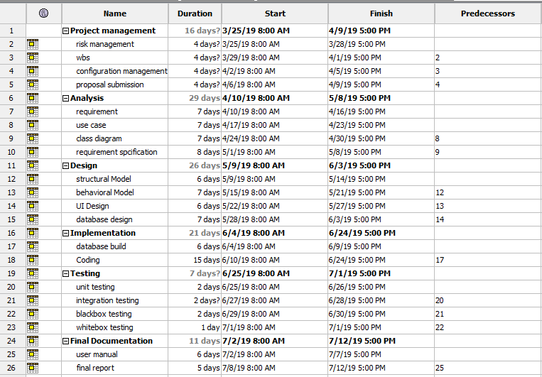

Figure :scheduling Gantt chart

### 4.3.2 Gantt chart

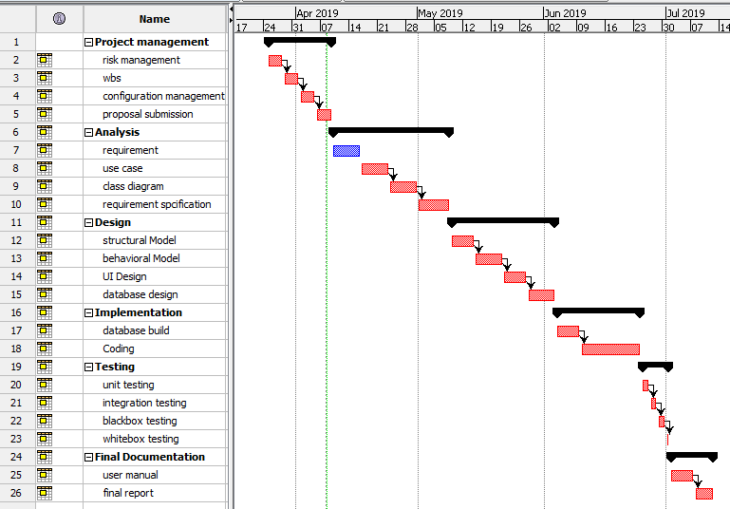

Figure :time estimation table

# 5. Risk management

Risk is the kinds of probability in which it takes on each and every sector. Identifying before it gets might be the possible solution. There are various factors that affect either natural or artificial.

For this task risk can be measure as:

**Impact= likelihood*consequences**

Likelihood as:

|  |  |
| --- | --- |
| Likelihood | Values |
| Low | 1 |
| Medium | 2 |
| High | 3 |

Consequences as:

|  |  |
| --- | --- |
| Consequences | Values |
| Very low | 1 |
| Low | 2 |
| Medium | 3 |
| High | 4 |
| Very high | 5 |

The risk and consequences are show below:

|  |  |  |  |  |  |
| --- | --- | --- | --- | --- | --- |
| S.N | Risk | Likelihood | Consequence | Impact | Solution |
| 1 | Server failure | 2 | 4 | 8 | Proper monitoring on devices |
| 2 | Natural disaster | 2 | 5 | 10 | Backup and safe place to protect |
| 3 | Equipment failure | 1 | 4 | 4 | Regular changes on equipment’s |
| 4 | Lack of skill manpower | 3 | 3 | 9 | Proper training should be given |
| 5 | Server failure | 1 | 5 | 5 | Regular maintenance |
| 6 | Out of requirement | 2 | 4 | 8 | Updating the requirement on time |
| 7 | Theft | 2 | 3 | 6 | Secure the data through backup and encryption |

# 6. Configuration management:

Configuration management is to gained the performance, functional and the physical attribute with design, requirement. It also makes the allocation of version control manages the changes of system over the system lifecycle. Quality management, system criteria and multiple version control made or not.

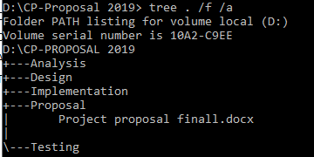

Figure :configuration tree of file

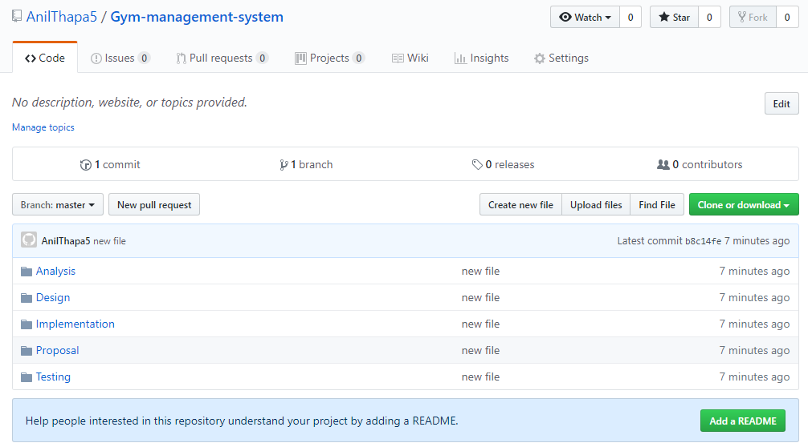

Figure : file uploaded to git

# 7. Conclusion

At last the task of proposal has been successfully done with the help of different references from different sources. Task has been provided with the different diagrams, time estimated schedules, Gantt chart to better understand. Function with its understanding can be detected with clearly. The project will finish on time with quality of product.